Project Management

# Directions

Complete the simulation found on the Assignment Manager page on the Pearson site.

## Suggestions

* For each activity, calculate the cost to expedite/crash each day
* Look at the critical path activities first
  + Obsessively obsess over the critical path
* Save some money for unplanned events during the building process

# Questions

1. What were the following results for the completed project?
   1. Project cost
   2. Project profit/loss in $ and %
   3. Project completion time
   4. Project status (days over/under)
   5. Decision accuracy
2. What was the original critical path? How did it change as tasks were expedited/crashed?
3. How was it decided which tasks to expedite/crash?
4. What was the homeowner morale? What factors impacted this?
5. Were the goals reached for the simulation? If not, how could it have been improved? If yes, then what was done that led to the success?

# Overview



## Summary Screen

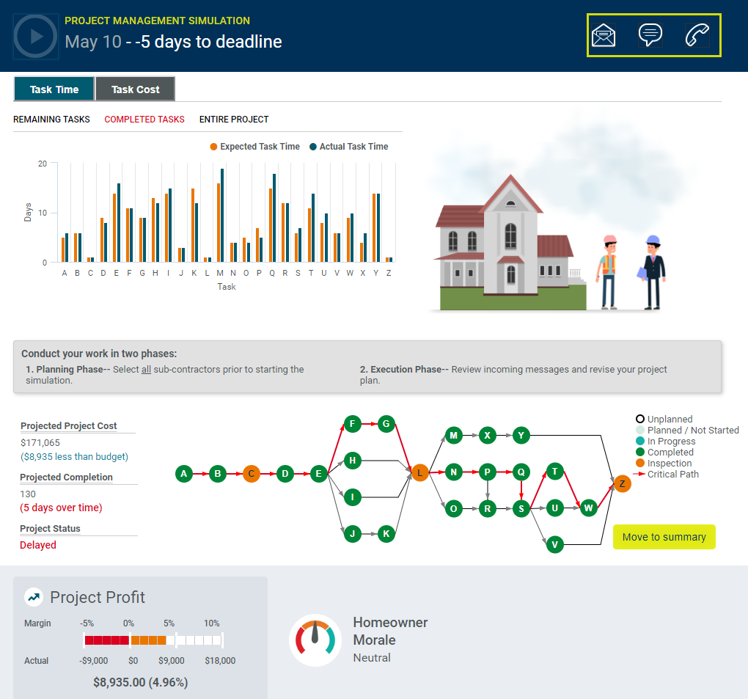

## Results­ – General Feedback

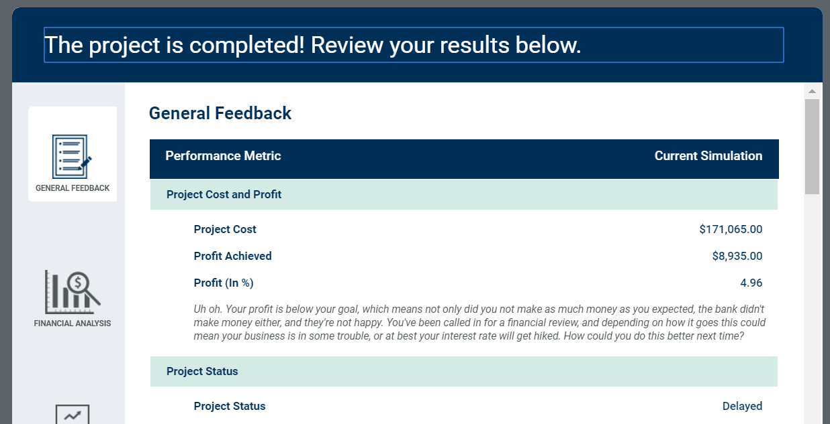



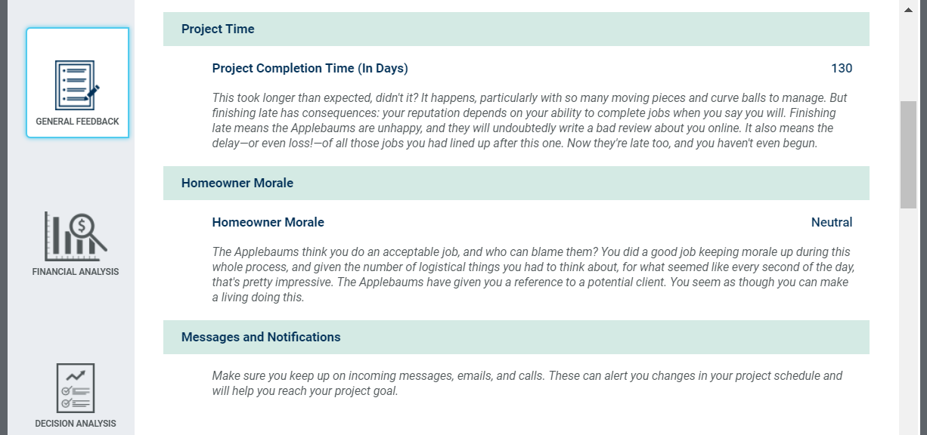

## Financial Analysis

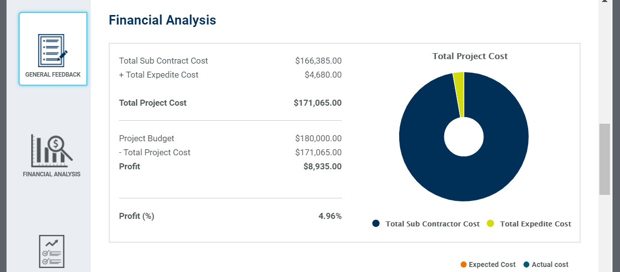

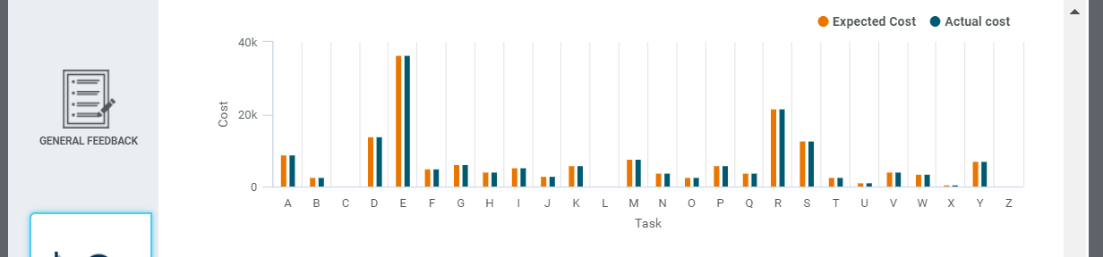

## Decision Analysis

